Dis-Eur-Paleo-Venus Figurines

*Paleolithic art of Europe and Asia falls into two broad categories: mural art and portable art. Mural art is concentrated in southwest France, Spain, and northern Italy. The tradition of portable art, predominantly carvings in ivory and antler, spans the distance across western Europe into North and Central Asia. It is suggested that the broad territory in which the tradition of carving and imagery is shared is evidence of cultural contact and common religious beliefs. Some of the most well known examples are the so-called Venus figurines. One such figurine, illustrated here, is from the site of Mal'ta and dates to around 23 000 BP. It is carved from the ivory of a mammoth, an extinct type of elephant highly prized in hunting that migrated in herds across the Ice Age tundra of Europe and Asia. Like most Paleolithic figurine carving, the image is carved in the round in a highly stylised manner. Typically, there are exaggerated characteristics such as breasts and buttocks, which may have been symbols of fertility. Height 87 mm.*Laura Anne Tedesco  
  
Department of Education, The Metropolitan Museum of Art   
  
Photo and text: http://www.metmuseum.org/TOAH/HD/malt/hd_malt.htm

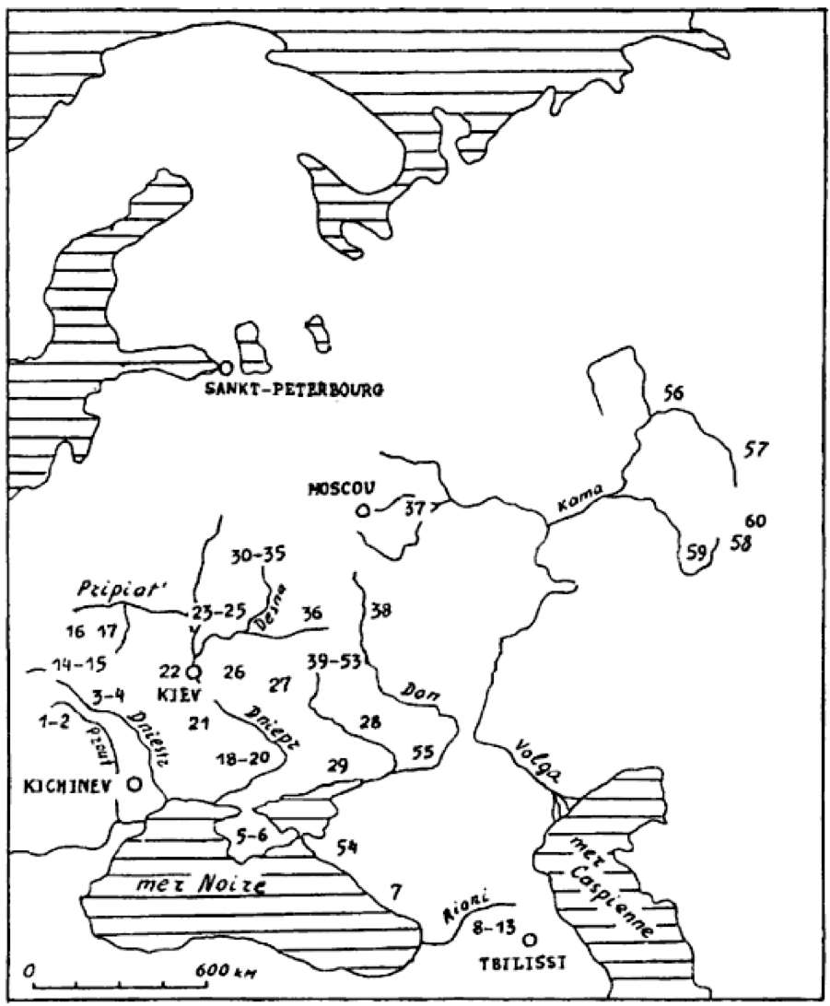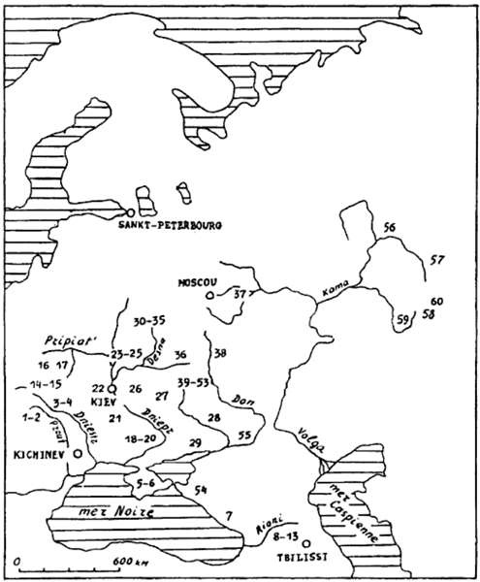  
  
Distribution of mobile art in Eastern Europe.   
  
1 Staryé Duruitory, 2 Brynzeny, 3 Kosseoutzy, 4 Klimaoutzy, 5 Suren' 1, 6 Chan-Koba, 7 Apiantcha, 8 grotte d'Uvarov, 9 Sakagia, 10 Sagvardgilé, 11 Gvardgilas-Kldé, 12 Devis-Khvreli, 13 Taro-Kldé, 14 Molodova V, 15 Lissitchniki, 16 Lipa VI, 17 Klinetz, 18 Ossokorovka, 19 Dubovaya Balka, 20 Kaïstrovaya Balka, 21 Mejiritch (Mezhirich), 22 Kievo-Kirillovskaya, 23 Mézine (Mezin), 24 Novgorod Severskyi, 25 Puchkari I, 26 Dobranitchevka, 27 Gontzy, 28, Rogalik, 29 Amvrossievka, 30 Eliseevitchi I, 31 Eliseevitchi II, 32 Yudinovo, 33 Khoylevo II, 34 Timonovka, 35 Suponevo, 36 Avdeevo, 37 Sungir', 38 Gagarino, 39 Kostienki 19, 40 Kostienki 21, 41 Kostienki 13, 42 Kostienki 1, 43 Kostienki 14, 44 Kostienki 12, 45 Kostienki 17, 46 Kostienki 2, 47 Kostienki 11, 48 Kostienki 4, 49 Kostienki 15, 50 Kostienki 9, 51 Kostienki 8, 52 Borchtchevo 1, 53 Borchtchevo 2, 54 Ilskaya, 55 Murakovka, 56 Ostrovskaya, 57 Bez'imyannyi, 58 Smelobskaya, 59 Kapova, 60 Ignatievskaya.   
  
Photo: [Abramova (1995)](http://www.donsmaps.com/malta.html" \l "reference)